UNHM MATH 422 Exam #1 NAME______________________________________________

Date_____________________________________

PLEASE REMEMBER:  Show your reasoning and/or math work in every problem. Some questions have more than one part. Make sure you answer every part of the question that was asked. You are being asked to calculate some things and interpret others.

1. (4 pts)

The total cost *C(q)*, in dollars, to produce *q* items is given by the function graphed below.

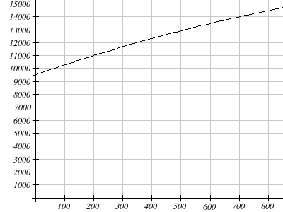

Find the average cost per item (the average rate of change) when increasing production from 200 units to 700 units.

Show your work here:

UNHM MATH 422 Exam #1 Page 2/8

2. (7 pts)

You have estimated the cost function for producing items will be , and expect to bring in $24 in revenue for each item sold. Assume you are selling as many items as you are producing.  
  
a) Find the cost of producing 300 items.  
  
b) How many items can be produced with a budget of $68,700?  
  
c) How many items need to be produced to break even?  
  
Show your work here:

UNHM MATH 422 Exam #1 Page 3/8

3. (6 pts)

The value of business furniture is assumed to depreciate (decrease) in value linearly.  The value was $44,000 in 2012 and $37,100 in 2015.

a) Find an equation for the value of the furniture.  Be sure to define your variables.

b) In what year will the value drop below $20,000?  Please solve algebraically! (in other words, don't guess-and-check or use a table of values)

Show your work here:

UNHM MATH 422 Exam #1 Page 4/8

4. (6 pts)

Suppose the quantity demanded, *q* , of a product when the price is *p* dollars is given by the equation   , and the quantity supplied is given by the equation  .  (Both q and p axes are labeled in hundreds of units)

a) Sketch the supply and demand curves

b) Find the equilibrium price and quantity.

Show your work here:

UNHM MATH 422 Exam #1 Page 5/8

5. (3 pts)

Bob just retired, and wants to move his $600,000 retirement into safer investments.  He has found a very safe municipal bond fund paying 3% interest, and riskier corporate bond fund paying 5% interest.  He wants to invest as ***little as possible*** in the riskier account but needs to earn $23,640 per year to live on. In one year, Interest = Principle * rate.

Write an equation that represents the situation (using only one variable, x) or a system of equations in two variables (x and y).  Be sure to define your x and y variables clearly.  You do not need to solve the problem, just set it up.

Show Your Work Here:

UNHM MATH 422 Exam #1 Page 6/8

6. (3 pts)

A regression was run to determine if there is a relationship between hours of TV watched per day (*x*) and the number of sit-ups a person can do (*y*).  The results were:

y = b+mx  
slope (m) = -0.79  
y-intercept (b) = 23.85  
r2 = 0.4887 (indicates the strength of the relationship)  
r = -0.6991

1. If a person watches 19 hours of television a day, predict how many sit-ups he can do.
2. If a person can do 9 sit ups, predict how many hours of television a day they watch.  
     
    hours

7. (3 pts)

Describe all the numbers that are in the domain of



UNHM MATH 422 Exam #1 Page 7/8

8. (4 pts)

Based on the table below,

|  |  |  |  |  |  |  |  |  |  |  |
| --- | --- | --- | --- | --- | --- | --- | --- | --- | --- | --- |
|  | 0 | 1 | 2 | 3 | 4 | 5 | 6 | 7 | 8 | 9 |
|  | 57 | 28 | 86 | 4 | 25 | 93 | 71 | 5 | 48 | 56 |

a. Evaluate =   
  
b. Solve =

9. (4 pts)

When , evaluate   
  
  

10. (4 pts)

Find the domain and range of the function graphed below. Give your answer in interval notation, or use a double inequality.  
  
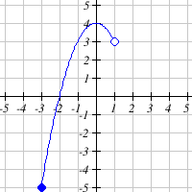  
  
Domain:  Range:

UNHM MATH 422 Exam #1 Page 8/8

11. (5 pts)

Write an equation for the graph below in terms of   
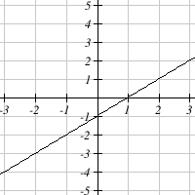

12. (1 pts)

Write the system of equations as an augmented matrix

+++++++++++++++

**Key - Form 1**

1. C(200) = 11000, C(700) = 14000. $6 per item
2. a) C(300) = 35,700  
   b) . q = 2500  
   c) . q = 3466.67
3. = 2300, giving the equation , where V is the value t years after 2012. Solving gives t = 10.43, so the value will be $20,000 in year 2022
4. 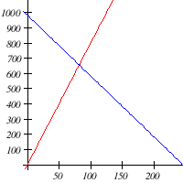

* Solving gives the equilibrium quantity of 82 at a price of $656

1. Letting be the amount invested in municipal bonds, and the amount invested in corporate bonds:  
    .  
     
   If you were to solve this, the answer is m = $318000, c = $282000
2. 9 ~ 18.8

License info at: <https://www.myopenmath.com/course/showlicense.php?id=98404-98405-98406-98407-98409-98383-98368>